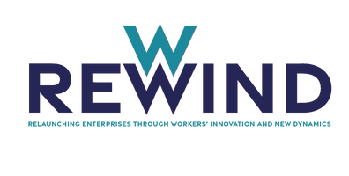



TextiTech Case Study

TextiTech is an SME dedicated to the manufacture of high-quality technical textiles. Its main focus is the production of innovative fabrics with advanced properties such as water resistance, self-cleaning capability and high temperature resistance. The company has experienced significant growth in recent years due to the demand for its specialised products.

Context
The company is in a crucial phase of expansion and diversification of its product line. To remain at the forefront of innovation in the textile sector, TextiTech is considering the implementation of new technologies and advanced manufacturing processes.

Training Challenge
With the introduction of new technologies and processes, TextiTech management recognises the urgent need to train its team in key areas. These areas may include adopting advanced textile technologies, understanding automated production processes and improving management skills to effectively coordinate these changes.

Training Objective
The objective is to ensure that employees are equipped with the skills necessary to implement and operate new technologies, as well as to effectively lead teams in a more advanced production environment.

Expected Benefits
The training is expected not only to improve the technical competence of employees, but also to foster an environment of continuous learning and adaptability throughout the company.
This situation provides the ideal context for employees to apply the training needs identification process and develop a comprehensive programme that ensures the alignment of staff skills with the company's strategic objectives.

rewindproject.net

